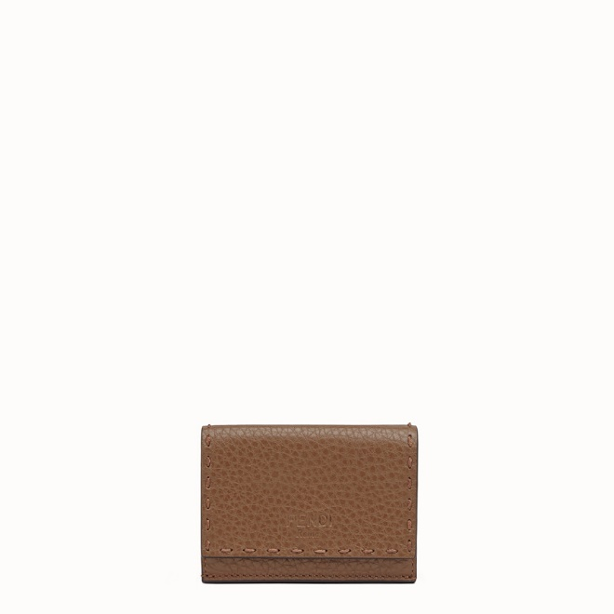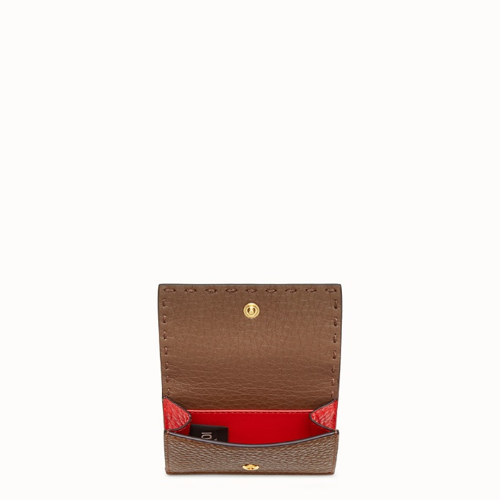

FENDI-MICRO TRIFOLD

$630.00

COLOR :Brown leather wallet  
SIZE : ONE SIZE  
IN STOCK

[Detail](http://127.0.0.1:60314/content/8kWUk-CMTa1lLcSKAAAa/TccMwTg/sE0tsH1/VKFdZmV/YhCBZIT#collapse)

Compact trifold Selleria wallet, with large internal bill compartment, three concealed card holders and an external coin purse with a press-stud fastening. Made of brown Romano leather, with tone-on-tone hand stitching. Contrasting two-tone lining. Gold-finish metalware.Made in Italy.

• Length:3.7 inches

• Height:3 inches

• Depth:1.2 inches

Universal Style: Product Code:8M0395SMTF1893

[CARE & COMPOSITION](http://127.0.0.1:60314/content/8kWUk-CMTa1lLcSKAAAa/TccMwTg/sE0tsH1/VKFdZmV/YhCBZIT" \l "collapse1)

• Leather

• Imported